

Food Waste Management Application

**Software Requirement Specification (SRS) Document Sprint Implementation**

**Project Timeline: 07.12.2022 to 13.12.2022**

A. Soumi Narayani

R. Shirisha

N. Navaneetha

M. Pravallika

J. Navitha

|  |  |
| --- | --- |
|  | **INDEX** |
| 1. Introduction |  |
| 1.1 Purpose | ------------------------------------------------ 5 |
| 1.2 Intended audience | ------------------------------------------------ 5 |
| 1.3 Intended use | ------------------------------------------------ 5 |
| 1.4 Scope | ------------------------------------------------ 5 |
| 2. Overall description |  |
| 2.1 Assumptions and dependency | ------------------------------------------------ 6 |
| 3. System feature and requirements |  |
| 3.1 Functionality | ------------------------------------------------ 6 |

* + 1. NGO
       1. NGO_Registration -------------------------------------------------6
       2. NGO_Edit -------------------------------------------------6
       3. NGO_View -------------------------------------------------6
    2. Hotel
       1. Hotel_Registration -------------------------------------------------7
       2. Hotel_Edit -------------------------------------------------7
       3. Hotel_View -------------------------------------------------7
    3. Admin
       1. NGO_Record_Maintainence
          1. Admin_NGO_Add -----------------------------------------7
          2. Admin_NGO_Edit ---------------------------------------- 7
          3. Admin_NGO_View -----------------------------------------7
          4. Admin_NGO_Delete ---------------------------------------7

* + - 1. Hotel_Record_Maintainence

3.1.3.2.1 Admin_Hotel_Add -----------------------------------7

3.1.3.2.2 Admin_Hotel_Edit -----------------------------------7

3.1.3.2.3 Admin_Hotel_View -----------------------------------7

3.1.3.2.4 Admin_Hotel_Delete -----------------------------------8

3.1.4 Admin_Report ---------------------------------------8

3.1.5 Admin_Check ---------------------------------------8

3.1.6 Food_Request

3.1.6.1 NGO_Request ---------------------------------8

3.1.6.2 Hotel_Request ---------------------------------8

3.1.6.1 NGO_Request --------------------------------8

3.1.6.2 Hotel_Request --------------------------------8

3.1.6.2.1 Yes --------------------------------8

3.1.6.2.2 No --------------------------------8

3.1.7 File Handling

3.1.7.1 NGO_File_Handling

3.1.7.1.1 NGO_to_list --------------------------------8

3.1.7.1.2 list_to_NGO --------------------------------8

3.1.7.2 Hotel_File_Handling

3.1.7.1.1 Hotel_to_list --------------------------------8

3.1.7.1.2 list_to_Hotel --------------------------------8

* 1. System requirement
     1. Tools to be used ----------------------------------------------------9
  2. System features ----------------------------------------------------9

1. Data flow Diagram
   1. DFD level 0 10
   2. DFD level 1 11

# Introduction: -

The introduction of the software requirement specification provides an overview of the entire software. The entire SRS with overview description purpose, scope, tools used and basic description. The aim of this document is to gather, analyze and give an in-depth insight into the complete Food Waste Management application by defining the problem statement in detail. The detailed requirement of the Food Waste Management application is provided in this document.

## Purpose: -

The purpose of this document is to show the requirements for the Food Waste Management application, in which either NGO requests the hotel/restaurant or the hotel/restaurant requests the NGO for the left-over food which is to be supplied for the needy.

## Intended Audience: -

This document is intended to be read by, NGO and hotel/restaurant And Admin.

## Intended Use: -

* + - NGO’s
    - Hotels/Restaurant
    - Admin

## 1.3 Scope:

This project aims to create the development of food waste management application. This reduces restaurant food wastage by giving leftover food to NGO’s. NGO’s will raise a request, in case of any left-over food restaurants have. This request is sent to the restaurant manager of that particular restaurant.

The NGO Manager then approves the request and assigns it to one of the NGO employees for takeaway and forwards the request to the restaurant. The leftover food at the restaurant can be given to NGO’s at the end of the day. The admin can track the history of restaurants and NGO’s for leftover foods.

# Overall Description:

A drastic increase can be seen in food waste. 1/3rd of food produced for human consumption is waste globally. As per WHO 20% of the population face extreme food shortages.Hence there is need to come up with the solution that can avoid food waste& can feed needy.

The Food Waste Management Application can assist in collecting the left-over food from hotels/restaurants to distribute among those in need.NGO’s that are helping poor communities to battle against starvation & malnutrition can rise a request for food supply from restaurants / hotels through this application.

Once the request in accepted, the NGO’s can collect the food from the restaurants / hotels for its distribution, in this way this Application will help the restaurants /hotels to reduce food waste and will help in feeding the poor and the needy people.

## Assumptions and Dependency: -

* + - System should have Ubuntu Linux installed.
    - · System should have either 4GB or more RAM.
    - The service is used preferably on a desktop or laptop or a mobile phone.

# System feature and requirements

## Functionality:-

## 3.1.1: NGO:

* + - 1. **:FW_01->NGO_Registration:**This feature allows the NGO to add new record.It

asks for the NGO registration id,name of NGO,number of beneficiaries, established year, office address and the telephone number.

* + - 1. **:FW_02->NGO_Edit:** This feature allows the NGO to edit basic details.
      2. **:FW_03->NGO_View:** This feature displays the details of NGO.

## :Hotel:

* + - 1. **:FW_04->Hotel_Registration**:This feature allows to add new hotel/ restaurant record.It asks for the hotel/restaurant registration id, name, address and contact details.
      2. **:FW_05->Hotel_Edit:** This feature allows the hotel/restaurant to edit the basic details.
      3. **:FW_06->Hotel_View:** This feature displays the details of hotel/restaurants.

## :Admin:

* + - 1. **:NGO_Record_Maintenance:**
         1. **:FW_07->Admin_NGO_Add:** This feature allows to add new NGO record by admin.It asks for the NGO registration id, name of NGO, number of beneficiaries, established year, office address and the telephone number.
         2. **:FW_08->Admin_NGO_Edit:** This feature allows to edit NGO’s record by admin, based on the registration id of the NGO’s, it help to modify the details such as number of beneficiaries, name, office address and the telephone number.
         3. **:FW_09->Admin_NGO_View:** This feature displays the details of NGO.
         4. **:FW_10->Admin_NGO_Delete:** This feature deletes the details of NGO based

on registration id.

## :Hotel_Record_Maintenance:

* + - * 1. **:FW_11->Admin_Hotel_Add:** This feature allows to add new hotel/ restaurant record by admin. It asks for the hotel/restaurant registration id,name,address and contact details.
        2. **:FW_12->Admin_Hotel_Edit:** This feature allows to edit the details of the hotel/restaurants like address, name, contact details by admin.
        3. **:FW_13->Admin_Hotel_View:**This feature displays the details of hotels/ restaurants.
        4. **:FW_14->Admin_Hotel_Delete:** This feature deletes the details of hotels/ restaurants based on registration id.
      1. **:FW_15->Admin_Report:** This feature will give a report on the number of requests for a day and display it. Also gives the name of the hotel / restaurants which got maximum requests.
      2. **:FW_16->Admin_Check:** This feature calls the NGO request function if the requested hotel can’t provide the food for that NGO.
      3. **:Food Request:**

**3.1.3.5.1:FW_17->NGO_Request:** This feature allows the NGO to request the left-

over food from the hotel /restaurant. If the request is accepted by the hotel/restaurant,

the confirmation slip is generated. If not the request will be forwarded to admin.

**3.1.3.5.2:FW_18->Hotel_Request:** This feature allows the hotel/restaurants to collect the left-over food.

**3.1.3.5.2.1:FW_19->Yes:** This feature gives confirmation regarding Hotel is

ready to supply food.

**3.1.3.5.2.2:FW_20->No:**This feature gives confirmation that Hotel cannot

supply food,So choose alternative hotel.

**3.1.3.6:File Handling:**

**3.1.3.6.1:NGO File Handling:**

**3.1.3.6.1.1:FW_21->NGO_to_list:** This feature allows to write NGO records to the

list.

**3.1.3.6.1.2:FW_22->list_to_NGO:** This feature allows to read NGO records from

the list.

**3.1.3.6.2:Hotel File Handling:**

**3.1.3.6.2.1:FW_23->Hotel_to_list:** This feature allows to write Hotel records to the

list.

**3.1.3.6.2.2:FW_24->list_to_Hotel:** This feature allows to read Hotel records from the

list.

## System requirements:

## Tools to be used:

* + - * C language
      * File Handling
      * Splint tool
      * Valgrind tool

## System feature:

* **Supportability:** The system is easy to maintain.
* **Design Constraints:** The system is built using only C language.
* **Usability:**Food Waste Management Application is used to request the left-over food from the hotels by NGO.And hotels/restaurants requests the NGO to collect left-over food.
* **Reliability & Availability:** The system is available when the user is requested for service.The system is available 24/7.
* **Performance:** The system will work on the user’s terminal**.**

## Data Flow Diagram:

## :DFD Level 0:

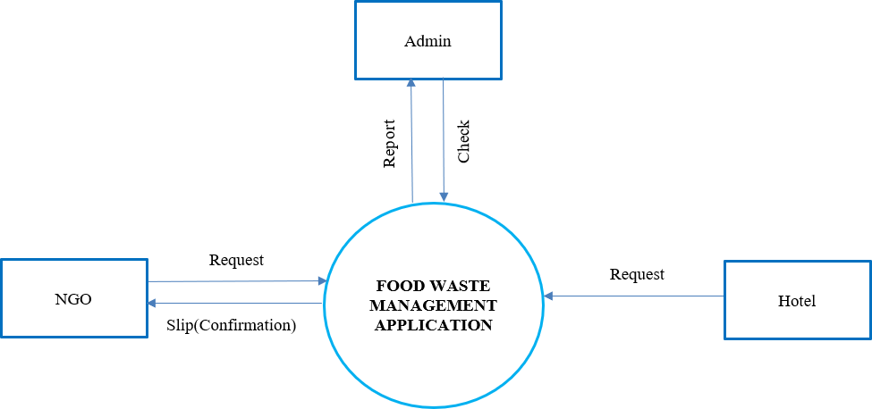

**4.2:** **1:DFD Level 1:**

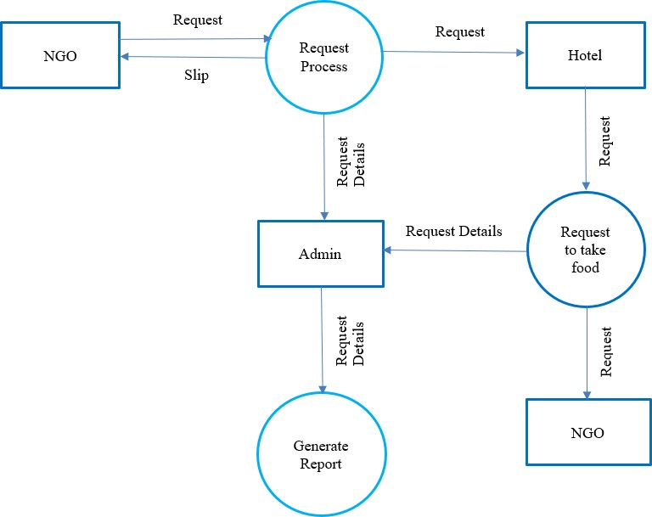

**SYSTEM ARCHITECTURE**

